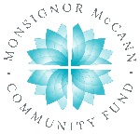
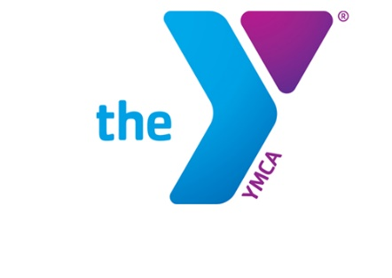

Newton YMCA/Monsignor McCann
Spring 2024 Youth Soccer Schedule -
U9 Girls

Team Coach Team Name Phone #
Team 1 Elizabeth Noga Red Stars 641-521-2702
Team 2 Nick McGinley Thunder 641-521-8099
Team 3 Hannah Bennett Thorns 641-521-4397
Team 4 Bridget Shoemaker Courage 641-840-2929
Team 5 Caroline Copenhaver Blaze 913-426-8530
Team 6 Erin Suttek Dream 641-840-1664

Time | April 13 | April 20 | April 27
12:00 pm | 2 vs 5 | 4 vs 6 | 2 vs 3
12:50 pm | 1 vs 4 | 3 vs 5 | 4 vs 5
1:40 pm | 3 vs 6 | 1 vs 2 | 1 vs 6
Time | May 4 | May 11 | May 18
12:00 pm | 1 vs 3 | 1 vs 5 | 2 vs 5
12:50 pm | 2 vs 4 | 2 vs 6 | 3 vs 6
1:40 pm | 5 vs 6 | 3 vs 4 | 1 vs 4

- All games played Saturday morning on YMCA fields
- League is 6 v 6 with including the goalie

Newton YMCA
1701 S. Eighth Ave. E
Newton, Iowa 50208
(p) 641-792-4006
(e) scott.taylor@newtonymca.org

