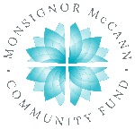
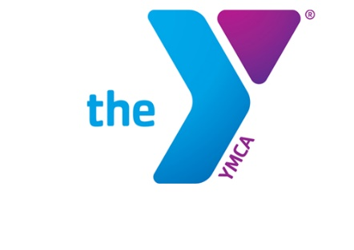

Newton YMCA/Monsignor McCann
Spring 2024 Youth Soccer Schedule -
U7 Boys Division II

Team Coach Team Name Phone #
Team 1 Cassidy Matthews Netherlands 641-840-0711
Team 2 Hannah Bartlett Italy 515-227-6781
Team 3 Kimberly Powers Brazil 515-347-8852
Team 4 Jordan Hadsall France 641-840-1908
Team 5 Sarah Pittman Chile 515-291-8534
Team 6 Andy Kueker Mexico 515-205-0670

Time | April 13 | April 20 | April 27
11:10 | 2 vs 5 | 4 vs 6 | 2 vs 3
12:00 | 1 vs 4 | 3 vs 5 | 4 vs 5
12:50 | 3 vs 6 | 1 vs 2 | 1 vs 6
Time | May 4 | May 11 | May 18
11:10 | 1 vs 3 | 1 vs 5 | 2 vs 5
12:00 | 2 vs 4 | 2 vs 6 | 3 vs 6
12:50 | 5 vs 6 | 3 vs 4 | 1 vs 4

- All games played Saturday morning on YMCA fields
- League is 4 v 4 with no goalie

Newton YMCA
1701 S. Eighth Ave. E
Newton, Iowa 50208
(p) 641-792-4006
(e) scott.taylor@newtonymca.org

