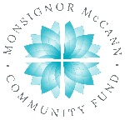
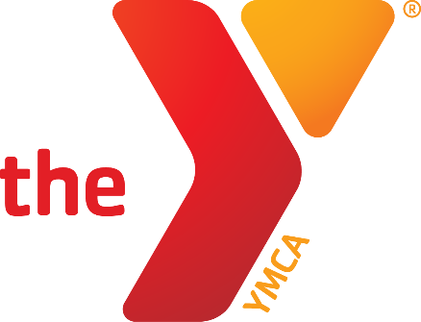

Newton YMCA/Monsignor McCann
Spring 2024 Youth Soccer Schedule
U12 Girls

Team Coach Team Name Phone
Team 1 Heather Fahrenkrug Angel City 641-840-0000
Team 2 Kayla Eicher Wave 641-521-4403
Team 3 Erik Camp Dash 641-417-9433
Team 4 Valerie Yeltman Pride 319-290-3152

Time | April 13 | April 20 | April 27
11:30 a.m. | 1 vs 2 | 3 vs 2 | 1 vs 3
12:30 p.m. | 3 vs 4 | 4 vs 1 | 2 vs 4
Time | May 4 | May 11 | May 18
11:30 a.m. | 2 vs 1 | 3 vs 2 | 1 vs 3
12:30 p.m. | 3 vs 4 | 4 vs 1 | 2 vs 4

- All Games played on Saturdays on YMCA game
- League will be 8 v 8 one is the goalie.
- Games consist of two 20 minute halves.

Newton Family YMCA
1701 S. Eighth Ave. E
Newton, Iowa 50208
641-792-4006
scott.taylor@newtonymca.org

