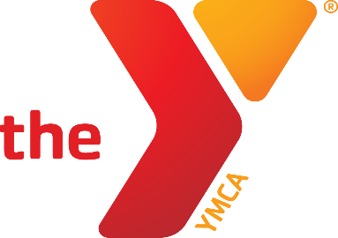

YMCA/Clemon-Maki/Lauterbach GMC
Spring 2024 Flag Football Schedule
4th-6th Grade

Team Coach Team Name Phone
Team 1 Tanner Briggs Titans 641 204 2919
Team 2 Blake Anderson Steelers 641 521 8568
Team 3 Brian Van Brogen Vikings 641 831 3614
Team 4 Robbie Robinson Cowboys 641 831 0297

Time | April 13 | April 20 | April 27
2:00 | 2 vs 3 | 1 vs 2 | 2 vs 4
3:00 | 1 vs 4 | 3 vs 4 | 1 vs 3
Time | May 4 | May 11 | May 18
2:00 | 2 vs 3 | 3 vs 4 | 2 vs 4
3:00 | 1 vs 4 | 1 vs 2 | 1 vs 3

- All Games played on Saturday afternoons on the high school fields that run along 8th Ave.

E-mail: scott.taylor@newtonymca.org
Newton YMCA
1701 S. Eighth Ave. E
Newton, Iowa 50208

641-792-4006
www.newtonymca.org

