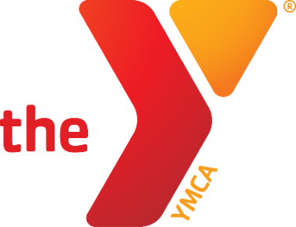
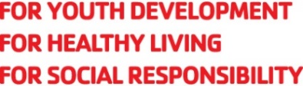

Hoop it up
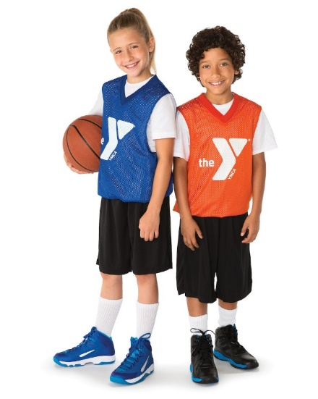
at the Y

SPORTS & RECREATION

Fall 2021 Session II Basketball League
Grades 2 – 6
Nov. 13 – Dec. 18

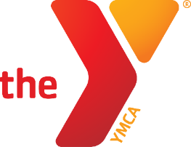
Newton YMCA 2021
Fall 2 Youth Basketball League

Who: Boys/Girls Grades 2nd – 6th (Divisions – 2 & 3, 4-6) Separate boys and girls divisions.
Practice: Practice Begins week of November 1
Games: Saturday Morning/Afternoon (one weeknight game)
When: November 13 - December 18 (No games Nov. 27) Happy Thanksgiving!
Fees: $28 Y Members, $48 Community Members
Deadline: Oct. 21, 2021
Questions? Contact Scott Taylor, Sports Director at (641) 792-4006 or scott.taylor@newtonymca.org

YMCA Fall Youth Basketball– 2021
Name: Gender: Grade (Fall 2021):
School: Height: Weight: Birthdate:
Address: City: Zip:
Parent Name(s): Phone#:
Email: Cell#:
Emergency Contact: Phone#: Relationship:
T-Shirt Size (circle): Youth: 6-8 (S) 10-12 (M) 14-16 (L) Adult: S M L XL
Please give a brief description of athletic ability, personality, size and other factors which may help us divide teams equally.
________________________________________________________________________________
Parental Release Agreement
I hereby certify that my child is in normal health and capable of safe participation in the youth sports program. I assume all risk(s) and hazards incidental to the conduct of this program and for the transportation to and from the program. I hereby authorize the YMCA to obtain medical treatment for my child in the event that parent(s) and the emergency contact cannot be reached.
I support the YMCA Youth Sports philosophy, which is based on participation, fun, physical fitness and health, skill development, teamwork, fair play, family involvement, and volunteer leadership.
I give the Newton YMCA permission to obtain pictures of my child while competing for the purposes of marketing the program.
Signature of Parent/Guardian Date
I am willing to volunteer in support of this program as a: Coach Co-Coach Referee Concessions
Name Phone T-shirt Size
OFFICE USE: Amt Pd: $ Cash Check # Charge Receipt # 01

