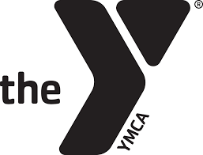
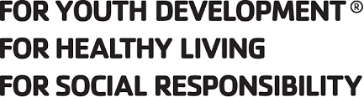
adding game
to fitness

SPORTS & RECREATION

Adult Men’s Basketball League 2022
Tuesdays, February 22^{ND –} April 5 (PLUS season ending tournament)

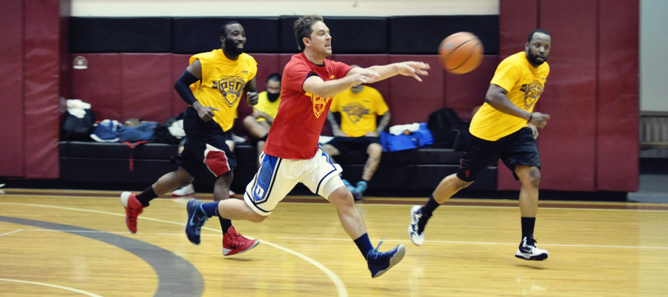

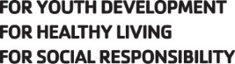

Adult Men’s Basketball League
This is a 5 v 5 full-court league. Teams are comprised of a Maximum of 8 players. There is a regular season plus season ending tournament. League jerseys are provided. We encourage teams to register as a team. If you are interested in playing and do not have a team, please contact Scott Taylor at scott.taylor@newtonymca.org or 641-792-4006.

Who: Men 9th grade and older
When: Tuesdays, February 22nd - April 5, 2022 (plus season ending tournament)
Where: YMCA Large Gym
Contact: Scott Taylor, Youth & Adult Sports Director at scott.taylor@newtonymca.org
Fee: $28.00 mEMBER $56.00 nONMEMBER
Deadline: February 12, 2021

Newton YMCA – Adult Winter Men’s Basketball League – 2022
Name: Gender: Birthdate:
Address: City: Zip:
Phone#: Cell#:
Emergency Contact: Phone#: Relationship:
Email: T-Shirt Size (circle): S M L XL 2X
Team Name: Team Captain:
Team Members: (Minimum 6 players; Up to 8 players on a team) Number of years in league:
1 4 7
2 5 8
3 6 9
I hereby certify that I am in normal health and capable of safe participation in the sports program. I assume all risk(s) and hazards incidental to the conduct of this program and for the transportation to and from the program. I hereby authorize the YMCA to obtain medical treatment for me in the event that the emergency contact cannot be reached.
I support the YMCA Sports philosophy, which is based on participation, fun, physical fitness and health, skill development, teamwork, fair play, family involvement, and volunteer leadership.
I give the Newton YMCA permission to obtain pictures of me while competing for the purposes of marketing the program.
Signature Date

