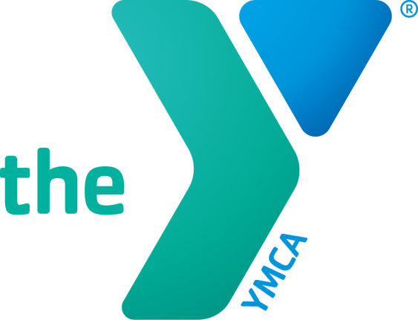
ROLLGA
Foam Rolling Workshop

Date: Saturday, June 30, 2018
Time: 9:30 AM-10:30 AM
Location: NEWTON YMCA – Studio B
1701 S. 8th Ave. E.
Newton, Iowa 50208

-Including a ROLLGA giveaway!
- Rollgas will be provided
-FREE TO members and non-members
over the age of 14

DO YOU HAVE SORE MUSCLES?
Join us for a fun, informative, hands-on
workshop designed to teach you everything you need
to know to successfully "roll" out your tight muscles using this unique foam roller.

Call or stop in to the NEWTON YMCA at 641-792-4006 or stop in to register!
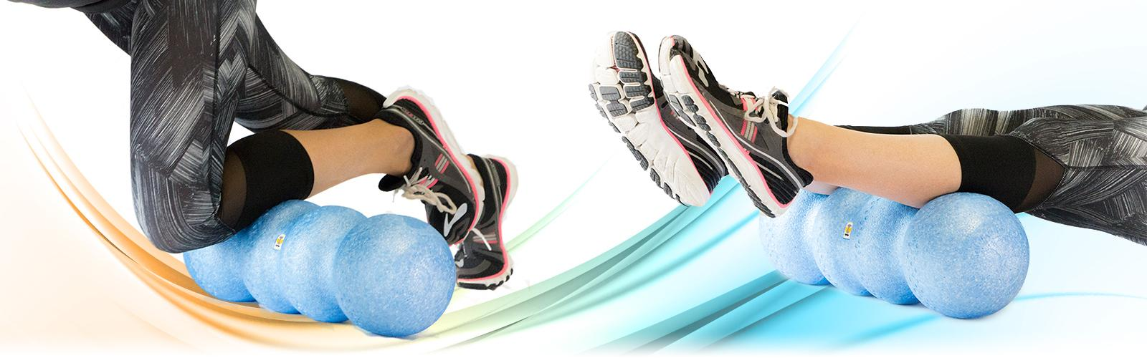
Only 10 spots available!

