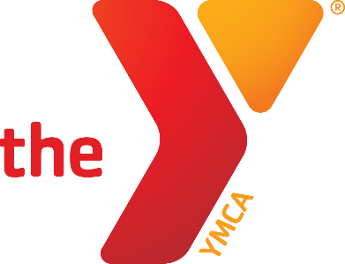

the ball
is in our
Court
SPORTS & RECREATION

Winter 2018
Mighty Mites Kindergarten Basketball
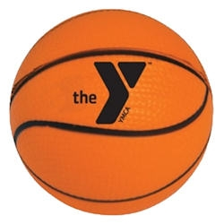

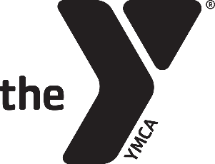
Shoot &
score

Mighty Mites Basketball

Don’t miss out on this fun and exciting program! This program entails skill building and fun games on Saturday afternoons. Having fun and learning skills is the focus! Volunteer coaches will instill the values of caring, honesty, respect and responsibility.

Who: Kindergarten Boy & Girls
Where: Newton YMCA Small Gym
When: Saturday Afternoon
January 13th – February 17th, 2018 (six straight Saturdays)
Fee: $23 Member$46 Nonmember

Contact: Scott Taylor at Scott.Taylor@newtonymca.org
- - - - - - - - - - - - - - - - - - - - - - - - - - - - - - - - - - - - - - - - - - - - - - - - - - - - - - - - - - - - - - - -
Mighty Mites Basketball – 2018
Name: Birthdate: Gender: Grade (Fall 2017):
Address: City: Zip:
Parent Name(s): Phone#:
Email: Cell#: School:
Emergency Contact: Phone#: Relationship:
T-Shirt Size (circle): Youth: 6-8 (S) 10-12 (M) 14-16 (L) Adult: S M L XL
Please give a brief description of athletic ability, personality, size and other factors which may help us divide teams equally.
___________________________________________________________________________________________________________________________________________________
Parental Release Agreement: I hereby certify that my child is in normal health and capable of safe participation in the youth sports program. I assume all risk(s) and hazards incidental to the conduct of this program and for the transportation to and from the program. I hereby authorize the YMCA to obtain medical treatment for my child in the event that parent(s) and the emergency contact cannot be reached.
I support the YMCA Youth Sports philosophy, which is based on participation, fun, physical fitness and health, skill development, teamwork, fair play, family involvement, and volunteer leadership.
I give the Newton YMCA permission to obtain pictures of my child while competing for the purposes of marketing the program.
Signature of Parent/Guardian Date

I am willing to volunteer in support of this program as a: Coach Co-Coach Referee Concessions

Name Phone T-shirt Size

