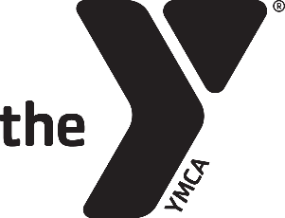
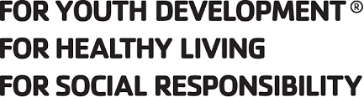
Having FuN
As A
Team

Winter 2020 Mighty Mights Basketball League
(Kindergarten & 1st Grade League)
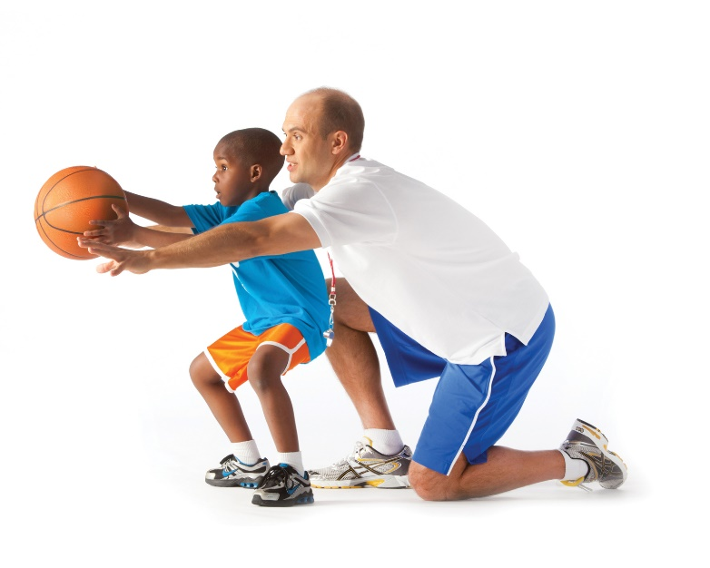

Shoot &
score

Mighty Mites Youth Basketball League

Don’t miss out on this fun and exciting league! Mighty Mites will meet six consecutive Saturday afternoons beginning January 18th. The first two meetings are forty – five minute practices. February 1, February 8, February 15 and February 22 we will have a short warm-up followed by a game.

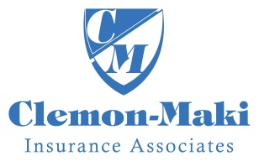
Who: Kindergarten & 1st Grade Boys & Girls
Where: YMCA Small Gym
When: Practice January 18 and January 25 afternoon
Games played Feb. 1, Feb. 8, Feb 15 & Feb 22
Fee: Before Dec. 18 $28 Member/$49 Nonmember
Beginning Dec. 18 $43 Member/$59 Non-member
Contact: Scott Taylor at scott.Taylor@newtonymca.org
- - - - - - - - - - - - - - - - - - - - - - - - - - - - - - - - - - - - - - - - - - - - - - - - - - - - - - - - - - - - - - - -
Winter Mighty Mites Basketball League – 2020
Name: ________________________________________________________________________ Birthdate: _______________ Gender: _______ Grade: ___________
Address: City: Zip:
Parent Name(s): Phone#:
Email: Cell#: School:
Emergency Contact: Phone#: Relationship:
T-Shirt Size (circle): Youth: 6-8 (S) 10-12 (M) 14-16 (L) Adult: S M L XL
Please give a brief description of athletic ability, personality, size and other factors which may help us divide teams equally.
___________________________________________________________________________________________________________________________________________________
Parental Release Agreement: I hereby certify that my child is in normal health and capable of safe participation in the youth sports program. I assume all risk(s) and hazards incidental to the conduct of this program and for the transportation to and from the program. I hereby authorize the YMCA to obtain medical treatment for my child in the event that parent(s) and the emergency contact cannot be reached.
I support the YMCA Youth Sports philosophy, which is based on participation, fun, physical fitness and health, skill development, teamwork, fair play, family involvement, and volunteer leadership.
I give the Newton YMCA permission to obtain pictures of my child while competing for the purposes of marketing the program.
Signature of Parent/Guardian Date

I am willing to volunteer in support of this program as a: Coach Co-Coach Referee Concessions

Name Phone T-shirt Size

