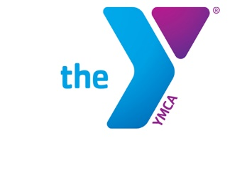
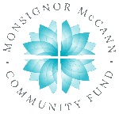

Newton YMCA/Monsignor McCann
Spring 2024 Youth Soccer
U9 Boys Schedule

Team Coach Team Name Phone #
Team 1 Fred Paton Manchester United 925-234-5546
Team 2 Courtni Davis Arsenal 515-444-7972
Team 3 Joesph Wright Liverpool 641-521-4905
Team 4 Audrey Rausch Chelsea 641-521-0722
Team 5 Simon Allison Wolves 515-478-5231
Team 6 Jenna Seals New Castle United 641-521-5819
Team 7 Nick Nabor Crystal Palace FC 515-664-0134
Team 8 Lindsay Howe Ashton Villa 641-521-6872

Time | April 13 | April 20 | April 27
8:30 | 7 vs 8 | 6 vs 8 | 5 vs 4
9:20 | 3 vs 4 | 5 vs 7 | 1 vs 8
10:10 | 5 vs 6 | 1 vs 3 | 7 vs 3
11:00 | 1 vs 2 | 2 vs 4 | 2 vs 6
Time | May 4 | May 11 | May 18
8:30 | 7 vs 2 | 7 vs 1 | 2 vs 3
9:20 | 3 vs 6 | 4 vs 6 | 8 vs 5
10:10 | 1 vs 5 | 3 vs 8 | 4 vs 1
11:00 | 8 vs 4 | 5 vs 2 | 6 vs 7

- All games played Saturday morning
- Games are played 6 v 6 with one player being the goalie
- Games consist of two 17-minute halves.

Newton YMCA, 1701 S. Eighth Ave. E., Newton, Iowa 50208
641-792-4006
scott.taylor@newtonymca.org

