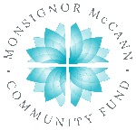
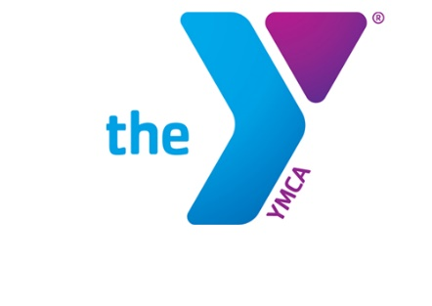

Newton YMCA/Monsignor McCann
Spring 2024 Youth Soccer Schedule -
U7 Boys Division I

Team Coach Team Name Phone #
Team 1 Caleb Marten England 641-888-0187
Team 2 Nate Werden South Korea 641-831-9647
Team 3 Jenna Heath Spain 641-521-0296
Team 4 Skyler Smith Turkey 641-831-9211
Team 5 Trenton McNeel Sweeden 712-358-0436
Team 6 Bridget Shoemaker Germany 641-840-2929

Time | April 13 | April 20 | April 27
8:30 | 2 vs 5 | 4 vs 6 | 2 vs 3
9:20 | 1 vs 4 | 3 vs 5 | 4 vs 5
10:10 | 3 vs 6 | 1 vs 2 | 1 vs 6
Time | May 4 | May 11 | May 18
8:30 | 1 vs 3 | 1 vs 5 | 2 vs 5
9:20 | 2 vs 4 | 2 vs 6 | 3 vs 6
10:10 | 5 vs 6 | 3 vs 4 | 1 vs 4

- All games played Saturday morning on YMCA fields
- League is 4 v 4 with no goalie.

Newton YMCA
1701 S. Eighth Ave. E
Newton, Iowa 50208
(p) 641-792-4006
(e) scott.taylor@newtonymca.org

