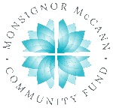
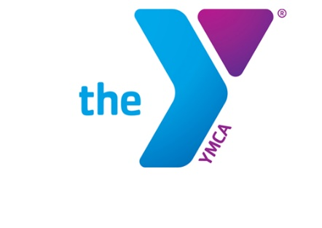

Newton YMCA/Monsignor McCann
Spring 2024 Youth Soccer Schedule -
Pre K 3 Year Old
Division II

Team Coach Team Name Phone #
Team 1 Jessica Samson Timberwolves 515-661-8526
Team 2 Jennah Heath Cheetahs 641-521-0296
Team 3 Ashlee Keeton Sharks 641-521-4268
Team 4 Nicole Woods Stingrays 515-321-3282
Team 5 Courtney Meyer Volcanos 515-696-6893
Team 6 Ashley Kern Wave 515-520-7630

Time | April 13 | April 20 | April 27
12:00 | 2 vs 5 | 4 vs 6 | 2 vs 3
12:45 | 1 vs 4 | 3 vs 5 | 4 vs 5
1:30 | 3 vs 6 | 1 vs 2 | 1 vs 6
Time | May 4 | May 11 | May 18
12:00 | 1 vs 3 | 1 vs 5 | 2 vs 5
12:45 | 2 vs 4 | 2 vs 6 | 3 vs 6
1:30 | 5 vs 6 | 3 vs 4 | 1 vs 4

- All games played Saturday morning on Pre K Field 2
- League is 3 v 3 with no goalie

Newton YMCA
1701 S. Eighth Ave. E
Newton, Iowa 50208
(p) 641-792-4006
(e) scott.taylor@newtonymca.org

