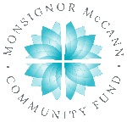
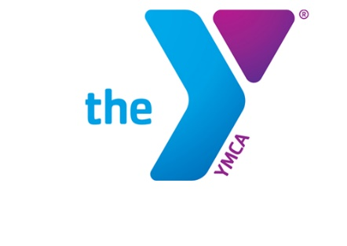

Newton YMCA/Monsignor McCann
Spring 2024 Youth Soccer Schedule -
U12 Boys

Team Coach Team Name Phone #
Team 1 Katrina Finch Galaxy 641-521-1757
Team 2 Nick McGinley Red Bulls 641-521-8099
Team 3 Ronivan Silva Fire 401-481-1881
Team 4 Kayla Eicher United 641-521-4403
Team 5 Nate Werden Revolution 641-831-9467
Team 6 Valerie Yeltman Rapids 319-290-3152

Time | April 13 | April 20 | April 27
8:30 am | 2 vs 5 | 4 vs 6 | 2 vs 3
9:30 am | 1 vs 4 | 3 vs 5 | 4 vs 5
10:30 am | 3 vs 6 | 1 vs 2 | 1 vs 6
Time | May 4 | May 11 | May 18
8:30 am | 1 vs 3 | 1 vs 5 | 2 vs 5
9:30 am | 2 vs 4 | 2 vs 6 | 3 vs 6
10:30 am | 5 vs 6 | 3 vs 4 | 1 vs 4

- All games played Saturday morning on YMCA fields
- League is 7 v 7 including goalie

Newton YMCA
1701 S. Eighth Ave. E
Newton, Iowa 50208
(p) 641-792-4006
(e) scott.taylor@newtonymca.org

