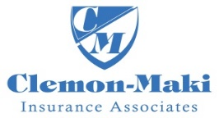
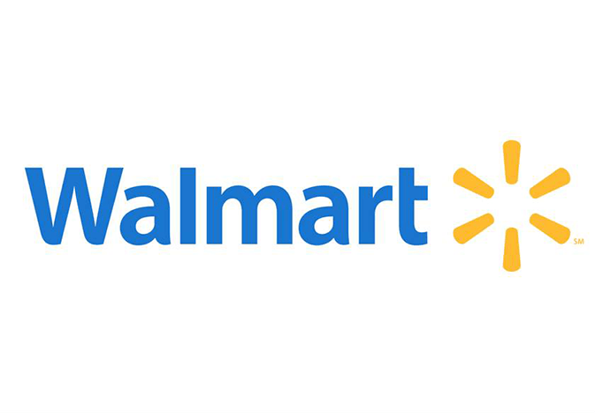
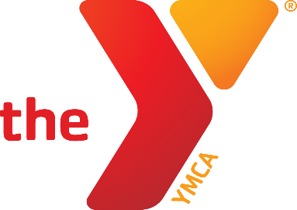

YMCA/Clemon-Maki/Wal Mart
Spring 2024 Flag Football Schedule
2nd & 3rd Grade

April 13th 1:00 Chiefs vs Raiders

April 20th 1:00 Chiefs vs Raiders

April 27th 1:00 Chiefs vs Raiders

May 4th 1:00 Chiefs vs Raiders

May 11th 1:00 Chiefs vs Raiders

May 18th 1:00 Chiefs vs Raiders

Newton YMCA
1701 S. Eighth Ave. E
Newton, Iowa 50208
www.newtonymca.org
scott.taylor@newtonymca.org

